**DEPARTMENT OF COMPUTER SCIENCE AND ENGINEERING**

**V SEMESTER-CIE 2 COMPONENT**

**Database Systems (CS52)**

**TERM-September-December**

**PROJECT PROPOSAL**

**09/11/2022**

**TEAM MEMBERS**

|  |  |  |
| --- | --- | --- |
| **S.NO** | **USN** | **NAME** |
| 1. | 1MS20CS014 | AMRTANSHU SHARMA |
| 2. | 1MS20CS025 | ARYAN MEHROTRA |

**LIBRARY MANAGEMENT SYSTEM**

**DISCRIPTION:**  Library management system aims to reduce the human efforts required in daily routine library works like issuing of books, maintenance of issued book records by converting the conventional paperwork into electronic format. The project will have a facility of admin login to monitor and maintain the whole system. Faculty login and Student login (Member id) will be there in the system through which both faculty and students will be able to issue books, see their issued books and corresponding return dates etc. The project will help the staff and students to be more efficient.

**OBJECTIVES:**

1. Students and Faculty will be made available a “Request column” for requesting the availability of new books or some more copies of the existing titles.
2. Students Faculty will be able to see their issued books and return dates along with their book issue limits.
3. System will have a “Search column” to search the availability of books.
4. Online book issue.
5. Reducing the risk of losing a file or damaging a file.

**ER-DIAGRAM OF THE PROPOSED SYSTEM:**

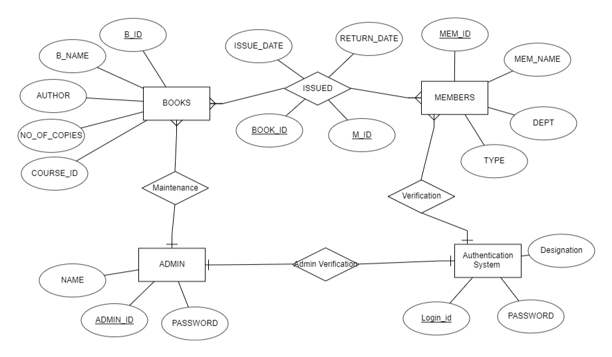

The above ER-Diagram represents 2 tables BOOKS and MEMBER which are related to each other through relation BORROWED_BY.

**BOOKS:** This table will include attributes attached with the book as B_ID, B_NAME, AUTHOR, NO.OF_COPIES, COURSE. B_ID is made primary key here because it is unique for every book.

**ISSUED:** BOOKS and MEMBER are related through ISSUED which has attributes ISSUE_ID, RETURN_DATA, BOOK_ID, M_ID. BOOK_ID is a foreign key which references BOOKS and M_ID is also foreign key which references MEMBER.

**MEMBERS:** This table will include attributes attached to the user/member of library i.e student or faculty. It includes attributes such as MEM_ID, MEM_NAME, DEPT, TYPE.

**Authentication System:** This table will help to verify the students , faculty and admin details , if details are correct they will be able to access the system according to their scope. It contains attributes such as Login_id, PASSWORD and Designation.

**ADMIN:** Admin table will contain details about admin who will maintain the library management system, He/she will be able to add to new books , remove books etc.

**SCHEMA TABLES FOR ENTITIES AND RELATIONS:**

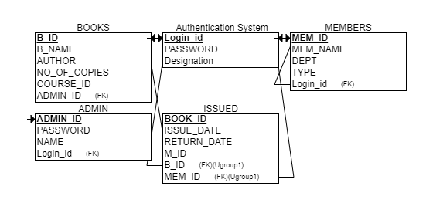

**RELATIONAL SCHEMA TABLES:**

**CONNECTIVITY:**

**FRONT-END;** Our front end for the library management will be made using HTML, CSS, JavaScript, jQuery framework will be used to add functionality.

**BACK-END:** In the back end we will be using MongoDB , Express.js, Node.js packages for maintaining the server and the database. Some other technologies like React.js may be used during the designing of the project.

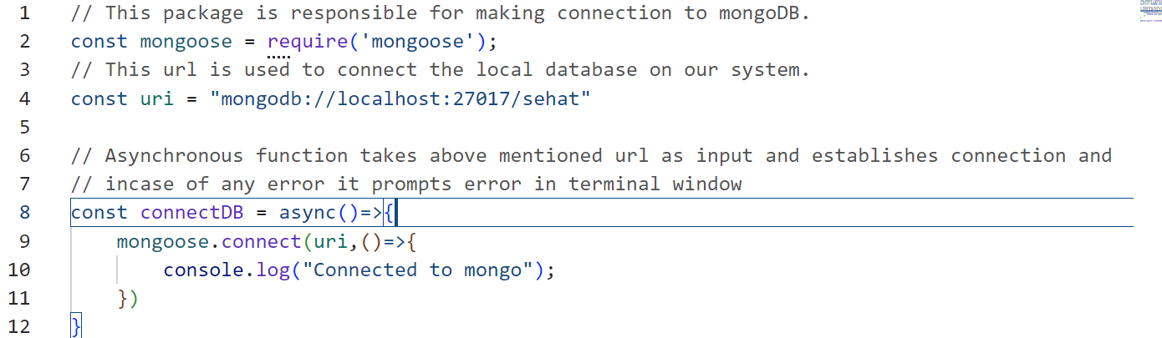

**FRONT-END WIREFRAME:**

**LOGIN PAGE:**

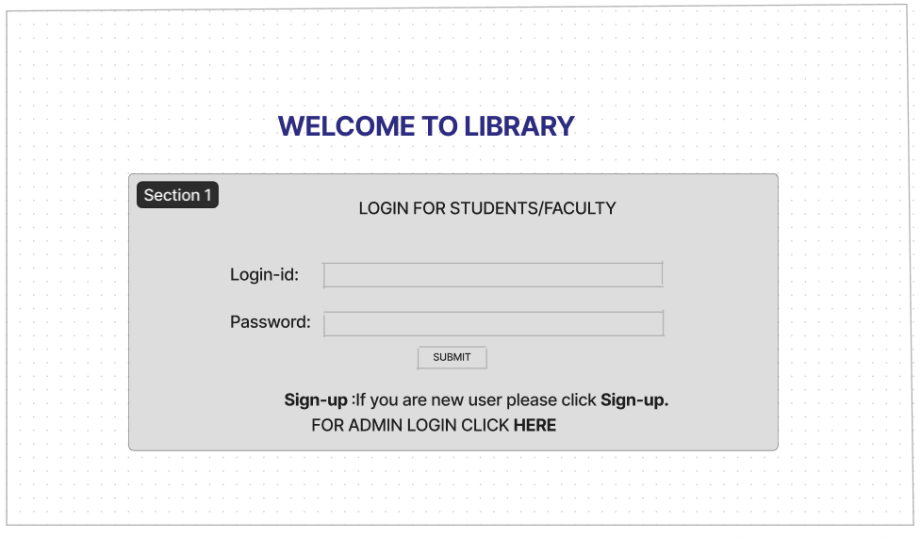

**SIGN-UP PAGE;**

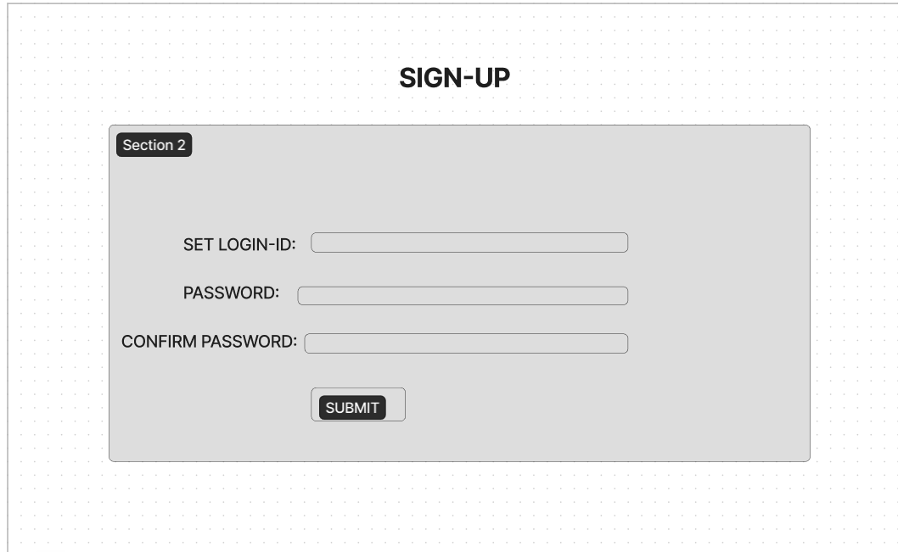

**CONFIRMATION PAGE:**

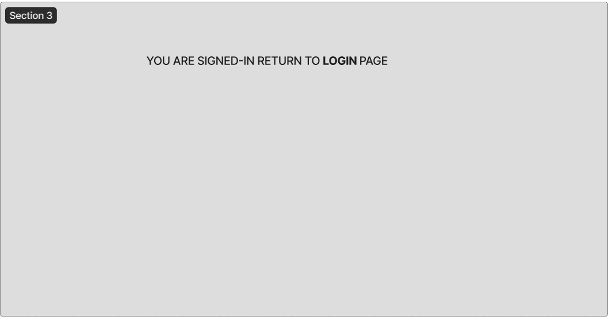

**FUNCTIONAL ISSUE/RETURN PAGE:**

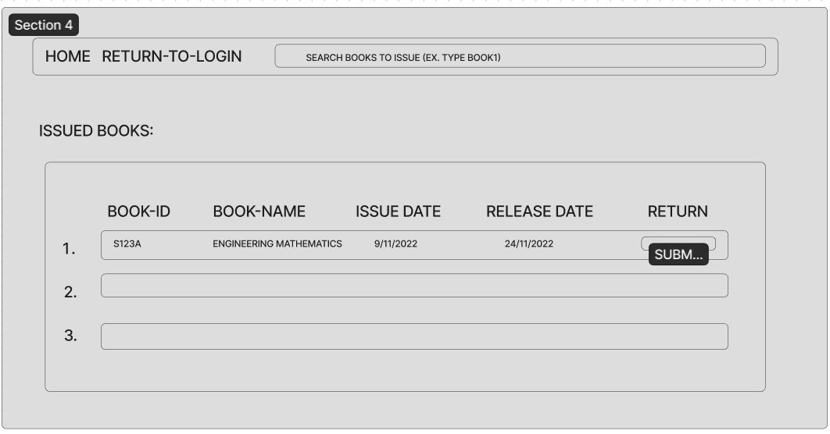

**ADMIN LOGIN PAGE:**

